
Robotic Pick and Place for Fruit Sorting
Applied Robotics (04 39984)
Group Members: Piero Flores; Yichang Chao; Ran Zhang; Zihen Huang

2.1 Application Background
The agricultural industry faces ongoing challenges with rising labor costs and efficiency limits, making automated fruit sorting an active area of development. While human operators traditionally performed highly repetitive pick-and-place tasks, this manual approach often yields inconsistent quality. Manufacturing has increasingly shifted toward robotic systems to improve throughput. By integrating machine vision with soft manipulation, these systems can handle delicate products without causing damage. Developing an automated sorting system directly addresses these industrial needs by applying robotics principles to practical automation.
2.2 Task Specification
This project uses the Quanser QArm, a four-degree-of-freedom manipulator equipped with a two-finger gripper and an RGBD camera. The objective is to sort three types of fruits randomly distributed in the workspace: a pack of six strawberries, three bananas, and five tomatoes. The system must identify the spatial coordinates of each fruit and transfer it to the correct basket. The final solution supports two operational modes. In the automated mode, the robot autonomously detects, locates, and sorts the items. In the remote-controlled mode, a human operator manually guides the robot through the same sequence.
3.1 Fundamentals of Robotics: Kinematics and Trajectory Planning for the QArm
This section establishes the mathematical foundation for the fruit-sorting pipeline. Higher-level behaviours, including vision-driven picking, state-machine sequencing, and teleoperation, ultimately reduce to determining the end-effector position for a given joint configuration (forward kinematics) and finding the joint configuration for a commanded Cartesian pose (inverse kinematics). Trajectory planning addresses how the joints should move between these configurations. The Quanser QArm used in this project is a 4-degree-of-freedom serial manipulator with a 2-finger gripper. Its limited redundancy makes an analytical treatment of these problems tractable and essential for real-time control at the 500 Hz loop rate required by the autonomous controller.
3.1.1 Kinematic Structure and DH Parameterisation
The QArm is modelled as an open kinematic chain of four revolute joints denoted $\phi_1 \dots \phi_4$, corresponding physically to the base yaw, shoulder pitch, elbow pitch, and wrist roll. Because the mechanical elbow has a small structural offset ($L_3 = 0.05$ m) that is not collinear with the upper arm ($L_2 = 0.35$ m), the manipulator does not map directly onto a textbook planar 3R arm. To avoid carrying this offset through subsequent derivations, we follow Quanser's recommended lumped-parameter convention and fold the upper-arm link and the offset into a single effective length,
$$\lambda_2 = \sqrt{L_2^2 + L_3^2} = 0.3536 \text{ m}, \quad \beta = \arctan(L_3 / L_2) = 0.1419 \text{ rad } (\approx 8.13^\circ)$$
while the base height and the concatenated forearm-plus-end-effector segment are kept as $\lambda_1 = L_1 = 0.14$ m and $\lambda_3 = L_4 + L_5 = 0.40$ m respectively. The geometric bias angle $\beta$ is later absorbed into the joint-angle offsets that relate the physical joint readings $\phi$ to the DH-frame angles $\theta$, via
$$\theta_1 = \phi_1, \quad \theta_2 = \phi_2 - \pi/2 + \beta, \quad \theta_3 = \phi_3 - \beta, \quad \theta_4 = \phi_4$$
The resulting standard Denavit-Hartenberg table is constructed with $a_1=0, \alpha_1=-\pi/2, d_1=\lambda_1$, $a_2=\lambda_2, \alpha_2=0, d_2=0$, $a_3=0, \alpha_3=-\pi/2, d_3=0$, and $a_4=0, \alpha_4=0, d_4=\lambda_3$.
The mechanical joint limits, enforced both in software clamps (qarm\_kinematics.py, JOINT\_LIMITS) and in the IK solver's validity check, are $\pm 170^\circ$ for $\phi_1$ and $\phi_4$ and $\pm 90^\circ$ for $\phi_2$ and $\phi_3$. These limits shape the reachable workspace into a truncated hemispherical shell of approximate outer radius 0.75 m, consistent with the workspace mapping reported in the interim deliverable (maximum horizontal reach 0.7536 m, maximum height 0.8936 m). Verification that all three basket positions and every feasible fruit location lie inside this feasible set is performed implicitly by the IK solver, which returns only configurations that satisfy the limits.
3.1.2 Forward Kinematics
Given a physical joint vector $\phi$, the end-effector pose in the base frame is the ordered product of four homogeneous transforms derived from the DH table:
$$T^0_4(\theta) = A_1(\theta_1) A_2(\theta_2) A_3(\theta_3) A_4(\theta_4)$$
where each $A_i$ is the canonical DH matrix constructed from $(a_i, \alpha_i, d_i, \theta_i)$. Expanding the product yields the closed-form position equations
$$p_x = \lambda_2 \cos \theta_1 \cos \theta_2 - \lambda_3 \cos \theta_1 \sin(\theta_2 + \theta_3)$$
$$p_y = \lambda_2 \sin \theta_1 \cos \theta_2 - \lambda_3 \sin \theta_1 \sin(\theta_2 + \theta_3)$$
$$p_z = \lambda_1 - \lambda_2 \sin \theta_2 - \lambda_3 \cos(\theta_2 + \theta_3)$$
which are also recovered numerically by reading the upper-right $3 \times 1$ block of $T^0_4$; the orientation is read from its upper-left $3 \times 3$ rotation block. At the home configuration $\phi = [0, 0, 0, 0]$ the forward model returns $p = [0.450, 0.000, 0.490]$ m and the rotation $R = [[0, 0, 1], [0, -1, 0], [1, 0, 0]]$, matching the teach-pendant readout on the lab QArm to machine precision.
Two properties of this formulation are practically significant. Because the manipulator only has four joints, the reachable orientations form a one-parameter family for a given target position. The wrist roll $\theta_4$ is effectively independent of position, prompting the IK routine to expose it as a user-settable argument $\gamma$ rather than solving for it. Additionally, the forward map is evaluated twice inside the inverse solver: once to compute the Cartesian residual and once through finite differences to assemble a numerical position Jacobian for iterative refinement.
3.1.3 Inverse Kinematics: Analytical Solution with Newton-Raphson Refinement
For a 4-DOF arm, the inverse kinematics is geometrically well-posed only for the position sub-problem (three equations and three free joints once $\gamma$ is pinned). We therefore decompose IK into two phases: a closed-form analytical seed, followed by a damped least-squares correction that absorbs any residual geometric inconsistency and compensates for numerical drift near singularities.
The analytical seed phase begins by projecting the target $p = (p_x, p_y, p_z)$ into the vertical plane containing the base axis, reducing the problem to a 2R planar inverse kinematics formulation in the variables $(D, H)$, where $D = \pm \sqrt{p_x^2 + p_y^2}$ is the horizontal reach and $H = \lambda_1 - p_z$ is the vertical drop from the shoulder joint. Applying the half-angle substitution to the standard two-link law of cosines yields four candidate solutions for $(\theta_2, \theta_3)$, corresponding to the combinations of left-reach or right-reach with elbow-up or elbow-down configurations:
$$\theta_3 = 2 \arctan2\left(-C \pm \sqrt{C^2 + F^2}, F\right), \quad F = \frac{D^2 + H^2 - A^2 - C^2}{2A}$$
with $A = \lambda_2$ and $C = -\lambda_3$. For each $(\theta_2, \theta_3)$ pair, the base yaw is recovered unambiguously from $\theta_1 = \arctan2(p_y/\delta, p_x/\delta)$ where $\delta = \lambda_2 \cos \theta_2 - \lambda_3 \sin(\theta_2+\theta_3)$. All four candidates are converted back to physical angles, wrapped into $[-\pi, \pi]$, and screened against the joint limits. Among the surviving configurations, the one minimising $\| \phi \|^2$ is selected. This cost functional biases the solver toward compact postures that keep the arm away from singularities and reduce unnecessary sweeping motions between pick and place operations.
To guarantee Cartesian accuracy at the tolerance of $10^{-6}$ m enforced by the convergence check, and to absorb residual drift near the workspace boundary where the discriminant $C^2 + F^2$ approaches zero, a Newton-Raphson update is applied in task space:
$$\Delta\phi = J^T (J J^T + \lambda I)^{-1} (p_{\text{target}} - p_{\text{current}})$$
where $J \in \mathbb{R}^{3 \times 4}$ is a three-point-stencil finite-difference Jacobian computed with a step size of $10^{-6}$, and $\lambda = 10^{-3}$ is a Levenberg-Marquardt damping factor that suppresses the near-singular inversion when the arm is close to full extension. Each iterate is re-clamped to the joint limits, and the wrist is held at the user-specified $\gamma$ so that it does not drift as a free variable.
Offline validation in validate\_python.py exercises the solver on six representative targets that span the three basket positions, the approximate workspace extremes, and the home pose. In every case, the solver converges inside the maximum iteration budget of 50 and satisfies the Cartesian tolerance of $10^{-6}$ m. For the nominal home pose, the round-trip check reported in the interim deliverable, FK(IK([0.450, 0.000, 0.490])) with resulting $\phi = [0, -0.028, 0.170, 0]$ rad, returns to the target at numerical precision ($< 10^{-10}$ m). No target in the validation set exceeds the 1 mm pass threshold adopted as the acceptance criterion for downstream pick planning.
3.1.4 Trajectory Planning: Quintic Polynomials with a Cubic Fallback
Once IK has produced a feasible joint vector for each waypoint, the motion between consecutive waypoints must be generated as a time-parameterised trajectory that the QArm can track at 500 Hz without inducing audible or mechanical jerk. Two polynomial blending schemes are implemented in trajectory.py. The autonomous FSM uses the quintic form by default, while the cubic form is retained as a reference baseline and is used for joint-space smooth\_move transitions.
The cubic baseline imposes zero velocity at $t = 0$ and $t = T$:
$$p(t) = p_s + \frac{3 \Delta p}{T^2} t^2 - \frac{2 \Delta p}{T^3} t^3, \quad \Delta p = p_e - p_s$$
Differentiation yields a symmetric bell-shaped velocity profile peaking at $1.5 \Delta p / T$ at the mid-segment, and a piecewise-linear acceleration that is finite but discontinuous at segment boundaries, which manifests in the drivetrain as an impulsive jerk each time a new segment begins.
To suppress this boundary jerk, the planner used at runtime (quintic\_trajectory in trajectory.py, called from sorting\_controller.py:337) raises the polynomial order to five with zero velocity and zero acceleration imposed at both endpoints:
$$p(t) = p_s + \Delta p \cdot s(\tau), \quad s(\tau) = 10 \tau^3 - 15 \tau^4 + 6 \tau^5, \quad \tau = t / T$$
The resulting acceleration profile is a single symmetric S-curve that vanishes at both ends, ensuring jerk stays bounded across segment concatenations. The unit-test test\_quintic\_boundary\_conditions in test\_integration.py verifies that $p(0) = p_s$, $p(T) = p_e$, and that both the first and second numerical derivatives are below $10^{-3}$ at the boundaries. This property is structurally impossible for the cubic baseline and is practically relevant because the geared drivetrain of the QArm amplifies jerk audibly and mechanically.
Segment durations are fixed constants inside sorting\_controller.py and shared with the simulation twin in sorting\_controller\_sim.py: $T_{\text{TRANSIT}} = 2.0$ s for long home-to-approach and basket transits, $T_{\text{APPROACH}} = 1.0$ s for the intermediate approach and basket-above moves, $T_{\text{PICK}} = 0.8$ s for the final vertical descent, and $T_{\text{DWELL}} = 0.5$ s for the quasi-static hold while the gripper actuates. The 2-second transit choice was inherited from previous experimental benchmarks, where shorter variants drove the commanded peak velocity and acceleration into actuator saturation, whereas $T = 2$ s maintained dynamics within the hardware envelope. The shorter 0.8 s descent for the pick is retained because the reduced vertical distance keeps the peak descent velocity below 0.25 m/s despite the compressed duration.
For movements where path shape in Cartesian space is less important than continuity in joint space, such as the initial trajectory issued by qarm\_driver.home(), the smooth\_move generator applies the cubic shape function $s(t) = 3(t/T)^2 - 2(t/T)^3$ directly to the joint vector. This avoids the computational overhead of running IK at every servo tick and guarantees continuity in configuration space.
Together, the DH-based forward model, the analytical-plus-refinement inverse solver, and the quintic trajectory generator form the deterministic spine of the control stack. Every perception-driven command issued by the FSM is ultimately expressed as a Cartesian target, passed through the IK solver to obtain a joint-space setpoint, and interpolated in time by the trajectory module before being written to the Quanser hardware-in-the-loop board.

## Simulink Implementation

### Vertical Slicing

**MATLAB–Python Bridge.** The model Fruitsorting_slice.slx verifies whether the inverse-kinematics bridge between Simulink and Python functions correctly. A target Cartesian coordinate [0.30; −0.20; 0.05] is fed into the input port p of the IK block. The block calls qarm_kinematics.py, which uses the DH parameters of the manipulator together with an analytical solver and Newton–Raphson refinement to obtain the four joint angles. A 4×1 array is produced at the output port phi and routed through output port 1 into a To Workspace sink, so that we can confirm whether the four joint angles return to the Simulink environment without data loss.
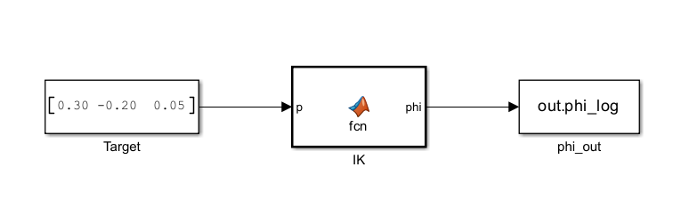
**Vision Link Verification.** The model Fruitsorting_slice_vision.slx validates the vision module and tracks the flow of image-recognition data. The Trigger block emits a one-shot signal that requests a single detection. Once the Detect block receives this signal, it invokes the background Python script fruit_detector.py, which reads a test image and processes it through HSV colour and shape recognition. The Detect block then outputs an 8×5 data matrix together with a scalar count. The matrix stores the identified fruit IDs along with their xyz coordinates, while the scalar reports how many fruits are actually detected. The results are archived in out.det\_log and out.count\_log, and both are forwarded to the MATLAB base workspace.
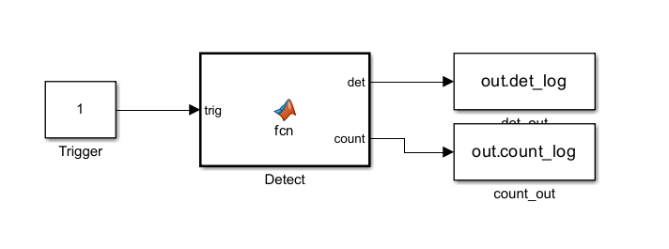
### Self-Driven Open-Loop Test Model

The model Fruitsorting_slice_fsm.slx checks whether the FSM logic on the Python side completes the entire sorting procedure as expected.

At every simulation step, an integrator accumulates a constant input of 1, producing a monotonically increasing integer sequence. This sequence serves as the tick signal supplied to the FSM and provides a discrete time base. When tick equals zero, a reset pulse is sent to the Python side so that the state machine is reinitialised, guaranteeing a clean initial state at the start of each test.

The FSM block bridges and invokes the controller script on the Python side. It takes the current tick and the joint angles from the previous cycle, phi\_prev, as its runtime inputs. After the internal logic evaluates these inputs, the block emits four control signals: the joint command for the next cycle, phi\_cmd; the gripper control signal, gripper; the current task-stage code, state\_id; and a Boolean flag, done, that indicates whether the procedure has finished. Four To Workspace blocks export these commands and state variables in real time and store them in the MATLAB base workspace. Once the simulation terminates, these variables are retrieved and plotted as timing diagrams, allowing us to assess whether the system states match expectations.

A phi\_delay block is also introduced so that the command issued in the current step, phi\_cmd, is delayed by one time step and fed back to the FSM in the next cycle as the previous position, phi\_prev. This emulates the state update that follows hardware execution and allows the state machine to advance continuously through the full sorting procedure.
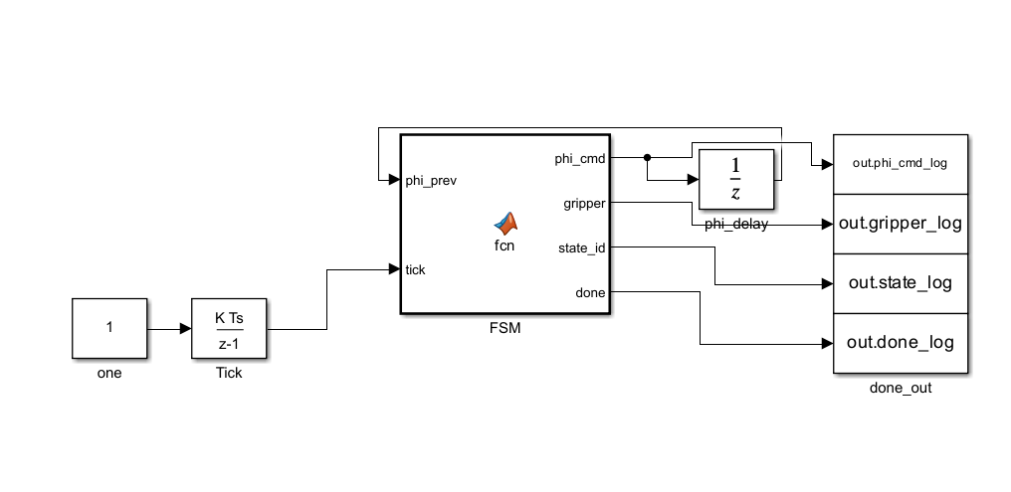
### Top-Level Integration and Hardware-in-the-Loop

The model FruitSorting\_Hardware.slx integrates the previously validated kinematics, vision, and FSM components, and connects them to the low-level hardware I/O.

The FSM block receives the current tick together with the measured joint positions of the manipulator, joints\_fb. Combining these signals with the data from the vision module, it computes where the arm should move next, phi\_cmd, whether the gripper should open or close, gripper, and broadcasts the current task progress through state\_id and done. The QarmIO block consumes the motion commands issued by the FSM, namely phi\_cmd and gripper\_cmd, and reads the mode switch qmode. After each command is executed, the block returns the outcome to the rest of the model, including the actual joint angles read back from the motor encoders, joints\_fb, and the gripper position. Five logging sinks, out.phi\_cmd\_log among them, record every command and feedback signal produced during execution and store them in MATLAB memory for subsequent scoring or trajectory replay.
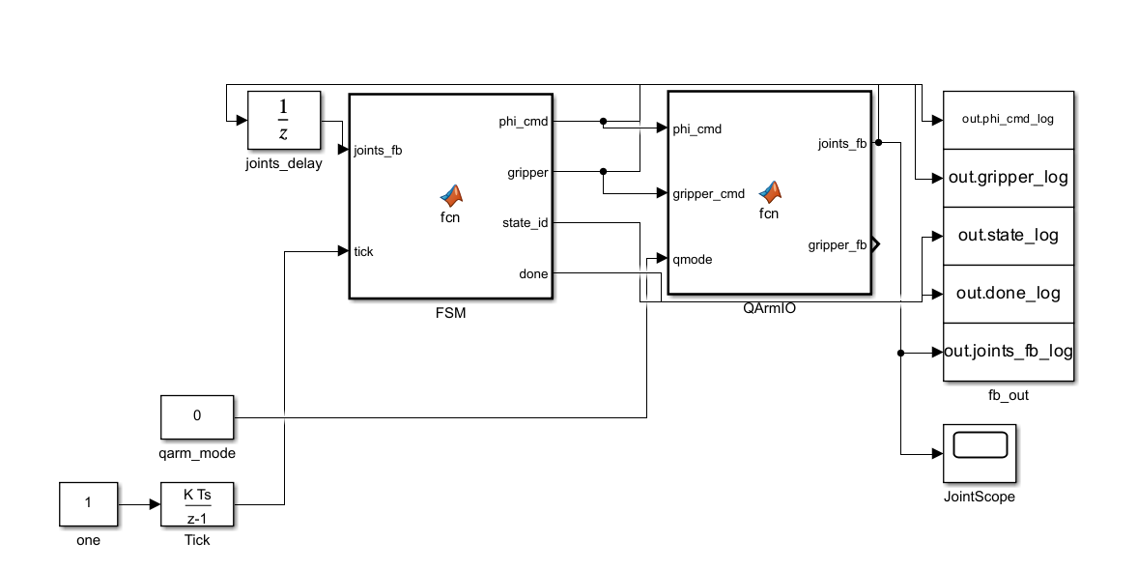

Part 1
The gripper design adopted in this project is based on the Fin Ray Effect, a biomimetic compliant mechanism in which structural ribs deflect toward an applied contact force. This behaviour arises from the internal cross-rib architecture, which redistributes compressive loads across the finger structure rather than concentrating stress at a single contact point, enabling passive shape conformance to irregular object geometries without active sensing. Two alternative soft gripper paradigms were evaluated prior to this selection. PneuNet actuators were excluded because the compressed-air supply infrastructure they require is incompatible with the QArm's existing Dynamixel XC430 servo-driven hardware, introducing unnecessary system complexity. Granular jamming, while effective for highly irregular geometries, does not admit closed-form mechanical analysis, making rigorous safety factor verification impractical within the scope of this coursework. The Fin Ray topology, by contrast, is analytically tractable under Euler-Bernoulli beam bending theory, integrates directly with tendon actuation via the XC430 servo, and requires no additional hardware beyond the existing manipulator platform.
The gripper comprises two symmetrical Fin Ray fingers, each 80 mm in length and 35 mm in width, a footprint determined by the largest target object, the tomato. Structural ribs are fabricated from TPU 85A via fused deposition modelling. With an elastic modulus of approximately 20 MPa, this material provides sufficient rigidity during grasp initiation while retaining the elastic compliance needed for sustained contact. Each rib has a rectangular cross-section with thickness graded from 1.5 mm at the fingertip to 2.0 mm at the base; this taper intentionally concentrates deflection toward the distal end, where conformance to object curvature is most critical. Rib lengths range from 15 mm at the tip to 30 mm at the base: shorter ribs near the contact zone limit tip deflection, while longer basal ribs provide the structural lever arm required for force transmission. The contact surfaces are lined with Silicone A30, a soft, food-safe elastomer with a conservatively estimated friction coefficient of μ = 0.6, ensuring reliable grip across the range of fruit surface textures encountered in this task. Total gripper mass is estimated at 60 to 80 g, remaining within the 100 g end-effector payload budget and preserving the effective working payload of the QArm.
Mechanical performance was evaluated through four analytical models, each addressing a distinct failure or functional criterion. The no-slip condition requires F_grip ≥ mg / (n·μ), where m is object mass, g gravitational acceleration, n the number of contact fingers, and μ the friction coefficient. With μ = 0.6 and n = 2, this establishes the minimum gripping force for each target object, verified in the safety factor analysis below. Contact stress at the finger-object interface is estimated using the Hertzian contact model, giving a peak pressure of P_max = 3F / (2πa²), where a is the effective contact patch radius; this provides an upper bound on surface stress against which the bruising threshold of each fruit can be checked. Rib deflection under load is modelled as a cantilever beam under Euler-Bernoulli assumptions, yielding tip deflection δ = FL³ / (3EI) and maximum bending stress σ_max = FL / (bh²/6), where L is rib length, E the elastic modulus of TPU 85A, and I = bh³/12 the second moment of area of the rectangular cross-section. Available tendon force is derived from the Dynamixel XC430 torque specification: adopting a conservative operating torque of τ = 0.5 N·m and a pulley radius of r = 5 mm gives a tendon tension of F = τ/r = 100 N, which comfortably exceeds the gripping force requirement across all target objects.
Two candidate rib thicknesses were evaluated under a representative load of F = 1 N. The 1.5 mm rib gives I = 5.625 × 10⁻¹³ m⁴, a tip deflection of δ = 0.46 mm, and a peak bending stress of σ_max = 33.3 MPa. While the deflection is mechanically permissible, the bending stress approaches the tensile strength of TPU 85A at roughly 30 to 40 MPa, leaving a low structural margin; this configuration was therefore judged functional but marginal. Increasing rib thickness to 2.0 mm reduces tip deflection to δ = 0.20 mm and peak bending stress to σ_max = 18.75 MPa, improving the stress margin at the cost of reduced finger compliance. The 2.0 mm thickness was selected as the baseline design, accepting the moderate reduction in passive conformability in exchange for greater structural reliability over repeated grasping cycles.
Safety factor was defined as SF = F_bruising / F_min, where F_bruising is the empirically established bruising threshold and F_min the minimum gripping force required by the no-slip condition. The banana yields F_min = 1.23 N against F_bruising = 10 N, giving SF = 8.1, reflecting its relatively firm peel and low density. The tomato gives F_min = 1.64 N and F_bruising = 5 N, with SF = 3.0; the lower margin is consistent with its thin, pressurised skin, which is more susceptible to localised stress concentrations. The strawberry package is the most demanding case: the aggregate mass of six strawberries raises F_min to 3.27 N, while the packaging material bruising threshold of 8 N gives SF = 2.4. This minimum safety factor holds only when Force-Sensitive Resistor feedback is active, confirming that closed-loop gripping force regulation is a necessary condition for safe strawberry package handling rather than an optional enhancement. Across all three object types, safety factors exceed unity by a sufficient margin, validating that the gripper can complete the pick-and-place task without inducing fruit damage under the specified operating conditions.

Chapter 5 Vision Module Design and Implementation

5.1 Introduction
The vision module is the core perception subsystem of the fruit-sorting robotic arm. Its job is to perform fruit recognition, pose estimation and base-frame coordinate projection on the RGB-D images provided by the Intel RealSense D415 camera. This project chose to build the module on classical computer vision techniques. By combining HSV colour segmentation, morphological operations, geometric feature filtering and solvePnP for extrinsic estimation, we built a processing pipeline that is light in computation and easy to interpret, while avoiding the training data and computing resources that a deep-learning model would require. This chapter explains, in order, the overall architecture of the vision module, the design of the thresholds, the camera calibration procedure, the runtime residual monitoring, and the implementation of the object-detection bounding boxes.

5.2 Overall Architecture of the Vision Module
The whole vision module is started from main_final.py. Inside, it connects camera.py, survey_capture.py, fruit_detector.py and picker_viewer.py in order, while session_cal.py is used to manage the calibration data in one place. Before the system starts, the offline calibration toolchain made up of calibrate_chessboard.py, calibrate_extrinsics.py and homography_solver.py must be run once to produce session_cal.json, which is then used as the calibration source at runtime.
On the hardware side, camera.py opens the D415 camera through the Video3D interface of the Quanser SDK. It starts a 1280×720 BGR colour stream and a uint16 depth stream in millimetres at the same time. Auto-exposure, auto white balance and the IR emitter are all turned on during initialisation, so that later HSV segmentation will not break when the lighting changes. The camera intrinsics (fx, fy, cx, cy) are read directly from the sensor when possible, and only fall back to hard-coded default values when the read fails. This step is important for the accuracy of the later pixel-to-base-frame projection.
After a BGR frame is captured, the pipeline first calls cv2.cvtColor(bgr, cv2.COLOR_BGR2HSV) to convert the image into the HSV colour space. Compared to RGB, HSV puts the hue into a single channel, which makes it more robust to brightness changes and therefore better suited as the basis for colour-threshold segmentation. After that, the system builds an HSV mask for each fruit class using cv2.inRange() to keep the pixels that fall in the range. For red targets whose hue crosses the H = 0/180 seam (tomato and strawberry body), two inRange calls are merged with cv2.bitwise_or. The raw mask still has small spots and holes from edge highlights and background noise, so a MORPH_OPEN (5×5 kernel) is applied to remove small noise points and a MORPH_CLOSE (9×9 kernel) is applied to fill the holes inside the fruit, keeping the contour boundaries complete.
The cleaned mask is then sent to cv2.findContours(mask, RETR_EXTERNAL, CHAIN_APPROX_SIMPLE) to get the outermost contours. Each contour must pass the geometric and colour gates of its class to become a valid detection candidate. The candidates that pass the gates are then sampled with sample_depth_at_pixel over a 5×5 patch to estimate the height of the fruit's top surface using the median depth. When the number of valid samples is too small, or the values fall outside a reasonable range, the system falls back to the per-class default heights stored in _FRUIT_TOP_Z_MM. Finally, pixel_to_base_frame combines the pixel and depth into a camera ray, rotates it into the base frame using the extrinsics solved by solvePnP, and intersects it with the target plane to obtain the (X, Y, Z) coordinate. The detector itself is stateless: each frame is processed independently, which gives the system good real-time performance.

5.3 Colour-Space Thresholds and Classification Conditions for Three Fruits
The colour and shape thresholds for the three fruit classes are all defined in the HSV_RANGES dictionary and a few module-level constants in fruit_detector.py. The HSV convention used by OpenCV is: H ∈ [0, 179], and S, V ∈ [0, 255]. Table 5-1 lists the HSV thresholds for each fruit, and Table 5-2 summarises the geometric and shape conditions.

Table 5-1 HSV Colour Thresholds for the Three Fruits
Class | H | S | V | Note
Banana | 14–40 | 80–255 | 60–255 | Hue shifts to ~15 under warm light, so the lower bound is loosened
Tomato | 0–10 ∪170-180 | 80–255 | 40–255 | Red crosses the seam, two segments merged with bitwise_or
Strawberry | 0–10 ∪170-180 | 30–255 | 15–255 | Shares the red range with tomato

Table 5-2 Geometric and Shape Conditions for the Three Fruits
Condition | Banana | Tomato | Strawberry
Min area (px) | 5 000 | 1 500 | 1 500
Max area (px) | 80 000 | 60 000 | 40 000
Aspect ratio | >= 1.5 (minAreaRect) | <= 1.8 (axis-aligned bbox) | 0.3 <= taper <= 3.5
Circularity (4πA/P²) | - | >= 0.4 | < 0.4 used as shape signal
Nearby green | - | green ratio in band above bbox <= 5% | green ratio > 5% OR shape signal
Centre point | bounding box geometric centre | first-moment centroid (cv2.moments) | centre of largest inscribed circle (cv2.distanceTransform)

The classification of bananas relies mainly on the "long, narrow and yellow" shape feature. The minimum area was first set to 800 px, but in real tests yellowed strawberry calyx leaves (about 1k-3k px and long-shaped) were often classified as small bananas. The threshold was therefore raised to 5 000 px, which keeps a four-times safety margin against real bananas (at least 20k px). The classification of tomatoes is mainly built on "round shape and no nearby green leaves". The circularity threshold was loosened from the original 0.7 to 0.4 to allow specular highlights that bite into the contour and reduce circularity. At the same time, an upper bound of 1.8 on the axis-aligned bounding-box aspect ratio was added to reject elongated red objects such as red chillies. The classification of strawberries is more complex because the calyx may face the camera or be hidden on the side. This study therefore uses a "green OR irregular shape" double-positive condition. It also uses cv2.distanceTransform to find the centre of the largest inscribed circle as the gripping target, so the gripper aims at the strawberry's wide body rather than the narrow tip. In addition, the detector computes calyx_dir_base_unit, which is the XY unit vector from the red centroid to the green calyx centroid, and passes it to the upper picker to fine-tune the grip offset.
To prevent a single contour from being labelled as more than one class, the three classes are mutually exclusive on both the shape axis and the colour axis: the tomato requires circ >= 0.4, while the strawberry's shape signal fires when circ < 0.4; the tomato requires no green nearby, while the strawberry requires green nearby or an irregular shape. The processing order is set as banana -> tomato -> strawberry, but because each detector runs on its own independent mask, the order only affects the reproducibility of the output list and does not change the classification result. Every candidate must finally pass the global threshold CONFIDENCE_MIN = 0.35 to be included in the detection output.

5.4 Camera Calibration Procedure
The accuracy of the vision module depends heavily on camera calibration, whose purpose is to build a precise mapping between "D415 pixels" and "robot base-frame 3D coordinates". This study uses an 8x6 chessboard (i.e. 7x5 inner corners, with 30 mm per square) as the calibration target, and divides the procedure into three phases.
Phase 1: origin registration. The operator manually jogs the robot arm and aligns the gripper tip with the top-left inner corner of the chessboard. After pressing the confirmation key, the system records the current TCP position as chess_origin_in_base_m. To avoid the systematic bias caused by assuming that the chessboard is strictly aligned with the base axes, it is recommended to also run touch_three_corners.py and touch the top-right (TR) and bottom-left (BL) corners. This allows solvePnP to estimate the extrinsics on the real board direction. All touch results are cached in logs/last_touched_tcp.json and logs/chess_touched_corners.json to support the --no-touch reuse mode, so the operator does not have to jog again every time.
Phase 2: image capture from the survey pose. The system reads the pre-taught survey1 joint angles from teach_points.json and calls slow_move_to_joints to move slowly to that pose, so that the camera extrinsics used during later detection match the ones solved here. To avoid sampling before the D415 stream is stable, the pipeline enters a warm-up phase and uses mean(color) > 5 as the condition for a valid frame. The system then captures 5 frames in a row and takes the pixel-wise median as the final captured frame, which suppresses random noise. The frame is also saved as logs/calibration_latest.png for later debugging.
Phase 3: parameter solving. First, cv2.findChessboardCorners is called with the CALIB_CB_ADAPTIVE_THRESH + CALIB_CB_NORMALIZE_IMAGE flags to detect the 35 inner corners, and cv2.cornerSubPix (5x5 window, up to 30 iterations, convergence threshold 0.01) is used to refine them at sub-pixel level. Then homography_solver.solve_homography solves the homography from pixels to the chessboard plane and returns the reprojection RMS. camera_height_from_homography further uses the Jacobian of H near the principal point to estimate the camera height above the table. The error is about 2% under a nadir view and about 15% within a 30° tilt.
The extrinsic estimation is handled by calibrate_extrinsics.solve_survey1_extrinsics, which calls cv2.solvePnPGeneric with the SOLVEPNP_IPPE flag. IPPE is a solver designed for planar targets and returns two candidate solutions at the same time. This study picks the one whose camera centre z is above the chessboard plane and whose RMS is lower. Because a 7x5 chessboard has direction ambiguity, OpenCV does not always start the corner indexing from the corner the user touched. The system therefore runs PnP for four (flip_i, flip_j) combinations (original, flipped columns, flipped rows, 180° rotation), and takes the best solution that passes all the gates listed in Table 5-3.
Table 5-3 RMS and Physical Sanity Gates in the Calibration Procedure
Gate item | Threshold | Action when not passed
Homography reprojection RMS | < 2.0 px | Warning, but still write the calibration file (suggest re-jog)
solvePnP reprojection RMS | < 5.0 px | Raise RuntimeError and refuse to write
Camera centre z coordinate | > chess_origin_z | Reject (the IPPE candidate must be above the board plane)
Distance from camera centre to survey1 TCP | < 0.25 m | Reject (physical limit of the wrist-mounted camera)

After all the gates are passed, run_calibration_core serialises the origin base coordinate, the homography, the survey joint angles, the chessboard parameters, the D415 intrinsics, the reprojection RMS, the camera height above the table, the image size, and the survey1 extrinsics (R_cam_in_base, C_cam_in_base_m) into session_cal.json, ready to be loaded at runtime.
There are several practical points to pay attention to during execution. First, the chessboard must lie completely flat on the table; any warping will increase the RMS a lot. Second, when jogging to touch the corner, make sure the gripper tip really makes contact, because a 1-2 mm error in the depth direction will be passed all the way to the base-frame coordinates. Third, auto-exposure can shift the HSV ranges, so the lighting during calibration and during later detection should be kept as similar as possible. Fourth, when the three corners are not touched, the pipeline implicitly assumes the chessboard is aligned with the base axes, but a tilt of more than 5° will already cause noticeable bias, so it is recommended to run the three-corner touch procedure every time. Finally, the 4-orientation sweep should not be skipped, because the direction ambiguity of a non-square chessboard can only be removed through a candidate search.

5.5 Runtime Calibration Residual Monitoring
Calibration is not "valid forever once it is done". During long working sessions, the robot arm may drift due to vibration, table movement or thermal effects in the D415. This project therefore introduces a runtime sanity-check mechanism in survey_capture.py, which verifies the calibration quality before each detection. Specifically, every time capture_fruits is called for a detection, it first moves the arm to the survey1 pose (the same as during calibration), captures the RGB and depth images, and then calls cv2.findChessboardCorners again. The detected corners are projected back to the chessboard plane through session_cal.h_pixel_to_chess_mm and compared with the nominal 30 mm grid to compute the residual in millimetres. The system then decides what to do based on the residual size, as shown in Table 5-4.
Table 5-4 Runtime Residual Levels and Actions
Residual | Status colour | System behaviour
< 3 mm | Green | Normal, continue with detection
3 mm <= residual < 10 mm | Amber | Add to warnings list, HUD shows a warning string
>= 10 mm | Red | Raise RuntimeError and force a re-calibration

Once the residual check passes, capture_fruits calls fruit_detector.detect_fruits(color, depth, session_cal) to obtain the detection list and returns the tuple (detections, diag) to the upper layer. Inside diag, residual_mm and diag.warnings are the data sources for the viewer's status light and warning text. This design changes calibration-quality monitoring from a "one-time check at start-up" into a "self-check on every frame", which clearly improves the long-term stability of the system.

5.6 Implementation and Visualisation of Object-Detection Bounding Boxes
The drawing of the detection boxes is not embedded inside fruit_detector.py; instead, it is intentionally separated into the _annotate() function in picker_viewer.py. This design keeps the detector clean - it only returns the geometric and classification results and does not pollute the original frame - and makes the visualisation an independent overlay that can be turned on or off freely. The Detection object returned by the detector already carries all the data needed for drawing, including bbox, center_px, confidence and fruit_type.
To make the three fruit classes easy to tell apart, each one has its own BGR colour. The HUD and warnings use neutral colours different from the fruit classes. The full colour scheme is shown in Table 5-5.
Table 5-5 BGR Colour Scheme Used in the Visualisation
Element | BGR value | Use
Banana | (0, 255, 255) yellow | Box, centre dot, label
Tomato | (0, 0, 255) red | Box, centre dot, label
Strawberry | (200, 100, 255) pink-purple | Box, centre dot, label
HUD text | (255, 255, 255) white | Top-left heads-up display
Warning overlay | (0, 180, 220) amber | Warnings list

The drawing core is a single for-loop. For each detection, three drawing operations are performed: cv2.rectangle draws the axis-aligned box obtained from cv2.boundingRect (line width 2 px); cv2.putText writes the "<fruit_type> <confidence>" label at the top-left of the box (font FONT_HERSHEY_SIMPLEX, scale 0.6, with LINE_AA for anti-aliasing); and cv2.circle(..., thickness=-1) draws a filled dot at center_px to mark the gripping target. The y coordinate of the label is intentionally set to max(18, y - 6) to keep the text from being cut off when the detection is close to the top of the image. The core code is shown below:
for d in detections:
color = _TYPE_COLORS.get(d.fruit_type, (255, 255, 255))
x, y, w, h = d.bbox
cv2.rectangle(out, (x, y), (x + w, y + h), color, 2)
label = f"{d.fruit_type} {d.confidence:.2f}"
cv2.putText(out, label, (x, max(18, y - 6)),
cv2.FONT_HERSHEY_SIMPLEX, 0.6, color, 2, cv2.LINE_AA)
cv2.circle(out, tuple(int(v) for v in d.center_px), 4, color, -1)
After the detections are drawn, _annotate() also draws the HUD at the top-left corner (showing the fruit count and a status string), and draws a status light at the top-right corner whose colour depends on the residual returned by survey_capture (the colour follows the levels in Table 5-4). If there are any warnings, they are stacked downward starting from coordinate (10, 56) with a 24 px line spacing.
In practice, two points must be respected in the visualisation layer. First, all drawing must be done on color_bgr.copy(), so that the next frame's detection input is not polluted by the previous frame's annotations, which could break the HSV thresholds. Second, the separation between annotation and detection allows the viewer layer to be extended without changing the detector. For example, to draw a rotated rectangle, one can get the four corner points with cv2.boxPoints(rect) and then draw them with cv2.drawContours. To show the strawberry calyx direction, one can use cv2.arrowedLine along the projected direction of calyx_dir_base_unit. To overlay an HSV mask for threshold debugging, one can convert the mask to colour with cv2.cvtColor(mask, COLOR_GRAY2BGR) and then blend it with the original image using cv2.addWeighted.

5.7 Chapter Summary
This chapter has explained in detail the design of the vision module of the fruit-sorting robotic arm. The overall architecture is built from camera.py (image capture), fruit_detector.py (the recognition core), survey_capture.py (runtime bridge and residual monitoring), picker_viewer.py (the visualisation layer), calibrate_chessboard.py together with its dependencies calibrate_extrinsics.py and homography_solver.py (the calibration toolchain), and session_cal.py (calibration data management). The study uses a lightweight approach of "classical computer vision + HSV thresholds + geometric gates + solvePnP", which gives every parameter a clear physical meaning, allows the parameters to be tuned step by step from real experiments, and keeps enough observability during debugging. The price of this design is that it is sensitive to lighting and object placement, so a careful calibration procedure and runtime residual monitoring are needed to compensate. By decoupling the visualisation of the detection boxes from the detector itself, the system keeps a good recognition performance while remaining easy to extend, and also provides a clean interface for adding new visualisation elements in the future.

6.Design and Implementation of the User Interface

6.1 Overview of the User Interface
The integrated control panel built on the Tkinter framework (python/main_gui.py) follows a two-column desktop layout. The left column hosts a real-time video feed from the D415 camera at a resolution of 640×360 pixels, while the right column groups the controls by function into several panels covering emergency stop, mode switching, manual teleoperation, gripper control, camera operations, and automatic sorting.

6.2 The Tkinter-based Integrated Control Panel

6.2.1 Overall Layout
The main window, titled QArm Fruit Sorting — GUI, is constructed with ttk.Frame and the grid geometry manager into a two-column layout. The left column (column=0) carries the video display, which consists of a tk.Label with a black background that continuously presents the 640×360 camera image. One subtle pitfall deserves explicit mention: when a Label widget is initialized without an image attribute, its width and height parameters are interpreted in character units rather than pixels, so a value of 640 corresponds to roughly 3840 pixels and is sufficient to push the right column off the screen. To prevent this, the _build_ui method preallocates a 640×360 black PhotoImage and assigns it as the initial image, a precaution that the source comments highlight explicitly. The right column (column=1) uses a ttk.Frame container with a padding of 8 and is divided from top to bottom by ttk.Separator instances into five functional regions: the emergency stop button, mode switching, manual teleoperation (covering XYZ jogging, basket positioning, gripper, and camera operations), the automatic sorting button group, and the status bar at the bottom.

6.2.2 Emergency Stop Mechanism
The emergency stop button sits at the top of the right column and carries the highest visual weight in the entire interface. It is implemented as a tk.Button labelled EMERGENCY STOP, with a high-contrast red background (#cc0000), white foreground, bold Arial 14 pt typography, height=2, and fill=“x” to span the full column width; its callback binds to _emergency_stop.
To address the trade-off in interrupt granularity inherent to real-time control systems, the emergency stop is realized through two layers of interruption. The first layer is a flag-based interrupt: a call to self.abort_event.set() raises the threading.Event so that every long-running worker thread, including teleoperation, basket motion, survey1, and the automatic mode, checks self.abort_event.is_set() at every loop iteration and returns immediately. The finite state machine receives the same check through controller.tick_observer. The second layer is a pose-freezing burst: because in-flight motion commands may still be propagating through the 200-step interpolation loop in slow_move_to_joints, the code reads the current joint angles and gripper state and writes them back to the driver repeatedly at ESTOP_FREEZE_REPEAT=30 iterations and ESTOP_FREEZE_INTERVAL=0.01 s, totalling roughly 300 ms.

6.2.3 Mode Switching
Mode switching is implemented as a binary selection through ttk.Radiobutton widgets, bound to self.mode_var, which is a tk.StringVar with an initial value of manual. When the user changes mode, _on_mode_change() iterates through the lists self.manual_buttons and self.auto_buttons and sets the state of every button in the active group to normal while disabling the other group. This mechanism eliminates command conflicts that would otherwise arise if the operator pressed manual teleoperation keys during automatic batch execution.

6.2.4 Manual Teleoperation
The manual teleoperation region is partitioned along physical-space dimensions into four subregions, responsible for Cartesian jogging, basket positioning, gripper control, and camera operations.
Cartesian XYZ jogging is realized by six buttons arranged in a 3×4 grid: Y+ and Z+ occupy row 0, X− and X+ occupy row 1, and Y− and Z− occupy row 2. Each press issues a displacement command of TELEOP_STEP_M = 0.02 m, that is 2 cm, with a fixed motion duration of TELEOP_SECONDS = 0.6 s and an interpolation count of TELEOP_STEPS = 40. The callback _teleop(dx, dy, dz) executes the following sequence: it clears abort_event, reads the current joint angles and gripper state from the driver, calls forward_kinematics to obtain the current end-effector position ee_pos, adds the increment (dx, dy, dz) to obtain the target new_pos, and then invokes inverse_kinematics(new_pos, gamma=0.0). If the inverse kinematics solver fails, the error is reported on the status bar and the function returns. Otherwise, _safe_move_to_joints interpolates the joints to the target pose, and the emergency stop is allowed to interrupt the motion at any point. On success the status bar displays Moved to ee = [x, y, z], and on failure it displays Teleop aborted (E-STOP).
Basket positioning is provided by a row of three buttons for Strawberry, Tomato, and Banana, each with width=10 and bound to _move_to_basket(fruit_type). The callback first reads the preset basket pose from controller.BASKETS[fruit_type], then performs inverse kinematics, and finally calls _safe_move_to_joints with a fixed duration of BASKET_SECONDS = 2.0 s.
Gripper control consists of two buttons, Open and Close, bound to _gripper_open and _gripper_close respectively. These methods invoke controller.set_gripper_ramp with GRIP_OPEN or GRIP_CLOSE. set_gripper_ramp issues a ramped command, which prevents the gripper from snapping abruptly to the endpoint and damaging the target object. Its return value, named actual, denotes the position actually held and is reported on the status bar.
The camera subregion contains two buttons. The Goto Survey1 button moves the manipulator to the imaging pose self.session_cal.survey_pose_joints_rad with a motion duration of SURVEY_SECONDS = 2.5 s; this pose is obtained from the camera calibration procedure and ensures that the D415 field of view covers the entire workbench. The Refresh detect button does not move the arm; instead, it directly invokes the hooked capture_fruits to perform the full sequence of image capture, checkerboard self-check, and fruit detection, and then summarizes the result on the status bar in the form Detected N fruits (banana=x, tomato=y, …).

6.2.5 Automatic Sorting
The automatic sorting region contains four buttons whose enabled and disabled states are managed jointly through the self.auto_buttons list. The ALL (B → T → S) button picks every banana, tomato, and strawberry in order and binds to _auto_all, while the remaining three buttons (Bananas only, Tomatoes only, Strawberries only) target a single category and bind to _auto_one(fruit_type).
Both callbacks first invoke _install_abort_observer() to register controller.tick_observer = _abort_observer. The observer checks abort_event at every FSM tick; once the flag is set, it forces controller.state to State.DONE and raises RuntimeError. This design is necessary because the underlying _drive_until_done only logs exceptions at warn level, so raising an exception alone does not stop the FSM. The state machine exits cleanly only when the DONE state causes the while-loop condition to fail. Notably, the execution body itself reuses picker_viewer._pick_category(driver, camera, session_cal, controller, fruit_type, should_abort_fn), which allows main_gui and picker_viewer to share the same implementation at the automatic batch layer and avoids the maintenance overhead of duplicate code.

6.2.6 Status Bar
The status bar resides at the bottom of the right column, implemented as a ttk.Label bound to a tk.StringVar named self.status_var, configured with wraplength=260 to enable line wrapping, and styled in dark green (#003300). Every long-running operation, whether successful or failed, updates the bar through the _set_status(msg) method. Internally this method uses self.root.after(0, lambda: …) to marshal the string onto the main thread, which avoids the RuntimeError: main thread is not in main loop exception that would otherwise arise from background threads operating directly on Tk widgets.

6.2.7 Video Refresh and Overlay
The video display is the most data-flow-intensive component of the GUI, involving two independent clocks and one transient cache.
The background camera-reading thread starts at the end of init as a daemon thread. Its target function _camera_loop calls self.camera.read() at CAMERA_LOOP_HZ = 30 Hz and stores the resulting BGR frame into self._latest_frame under the protection of self._frame_lock. Once self._camera_paused is set, the thread skips reading and only sleeps for one period. The reason for this design is that the Quanser Video3D driver is not thread-safe, so concurrent reads during capture would produce corrupted frames.
The UI-side video refresh runs on the main thread, where self.root.after(int(1000/UI_REFRESH_HZ), self._update_video) forms a recursive callback chain at 20 Hz. The priority logic of _update_video is as follows: if the most recent capture occurred no more than OVERLAY_LINGER_S = 5.0 seconds ago, the most recent capture frame with the detection overlay is shown; otherwise the system falls back to the live frame without the overlay. After acquiring the frame, the code first scales it from the native resolution to 640×360 with cv2.resize, converts the colour space to RGB through cv2.cvtColor, wraps it as an ImageTk.PhotoImage via PIL.Image.fromarray, and finally writes it to self.video_label.image to retain the reference. This last step cannot be omitted, since otherwise Tk garbage-collects the image object and the display turns black.
The detection overlay is drawn in place on the frame by _draw_overlay, which renders three elements: a bounding-box rectangle through cv2.rectangle with line width 2, a text label containing the class and confidence at font size 0.6 with thickness 2, and a filled circle at the centre point with radius 4. Colours are differentiated by fruit class through the _TYPE_COLORS dictionary: banana corresponds to BGR yellow (0, 255, 255), tomato to BGR red (0, 0, 255), and strawberry to BGR pink-magenta (200, 100, 255). The overlay appears only after the _on_capture hook is invoked by capture_fruits and writes the frame, the detection list, and the timestamp into _last_capture_frame, _last_detections, and _last_capture_time. The callback uses frame.copy() to clone the current frame, which prevents subsequent read() calls from overwriting it during the five-second linger period.
ESTOP_FREEZE_INTERVAL = 0.01 s jointly determine the total duration of the emergency-stop pose-freezing burst, which evaluates to 30 × 10 ms = 300 ms.

4.1 Test Methodology
The project did not include a Simulink dynamic simulation of the QArm hardware, so a conventional sim-to-real comparison was not possible. To still characterise the system properly, we designed a layered testing strategy on the physical robot.
Four test modes were used. The first mode was a single-fruit fixed-position pre-trial, in which each fruit type was placed alone at six workspace points (P1 to P6) one at a time. The second and third modes were two autonomous repeatability runs, each with a full set of 14 fruits in standard upright placement. The fourth was an autonomous robustness run that intentionally introduced adversarial placements such as adjacent, inverted, and rotated fruits. Finally, a teleoperation test was carried out by two human operators. These four modes together cover both the best case and the worst case of the system, and they let us isolate where each kind of failure actually comes from.
The hardware and software setup was as follows. The platform was a Quanser QArm 4-DOF manipulator with a rigid two-finger gripper, paired with an Intel RealSense D415 stereo-IR depth camera mounted overhead. A 7×5 inner-corner chessboard (8×6squares at 30 mm) served as the calibration fiducial. The protocol for each autonomous run started with running session_cal.py with a chessboard touch-probe to align the camera frame to the QArm base frame, after which the fruits were placed by hand on the workspace and photographed for the ground-truth record. The picker was then started in ALL (B → T → S) mode, which sequentially clears all bananas, then all tomatoes, then all strawberries. During the run we logged every detection frame, every PICK_ATTEMPT event, the commanded and read-back gripper closures, and the joint angles at grip and release. After the run, two team members independently checked the photographs against the basket contents and the log, and any discrepancy between the log and the visual record was resolved in favour of the visual record. This protocol was important because we found early in testing that the controller reports a successful "Placed" event even when the gripper has closed empty: the controller cannot directly tell whether anything is between the fingers, only that the gripper command was issued and the lift-and-release motion completed. The visual-record check is therefore the single source of truth for grasp outcomes in this section. This is also why the per-attempt grasp success rate (33/46 = 71.7%) is reported separately from the per-fruit task completion rate (33/41 = 80.5%): the same fruit can generate multiple attempts in the log, and the two metrics tell different stories about the system.
The metrics used in this section are defined as follows. Classification accuracy is the number of fruits whose category was correctly identified by the detector, divided by the number of fruits in the workspace. Grasp success rate is reported in the two ways described above (per-attempt and per-fruit). Basket placement accuracy is the proportion of picked fruits that were dropped into the correct basket. Task completion rate is the end-to-end metric, defined as the number of fruits both picked and placed in the correct basket, divided by the total number of fruits in the workspace. Cycle time is the average duration of one pick-and-place loop. Each completed pick was verified by direct visual observation rather than by trusting the controller's "Placed" log line.
We also recorded the gripper stall value from each pick attempt, defined as the difference between the commanded gripper closure and the actual readback. As shown later in this section, this single value turned out to be a useful diagnostic signal for separating different failure modes.
4.2 Pre-Trial: Single-Fruit Fixed-Position Performance
The pre-trial was designed to isolate the lowest-level question: given a single fruit placed at a known location, can the system pick it up? This removes multi-target scheduling, adjacency effects, and visual clutter, so any failure here points to a fundamental capability problem rather than a planning issue.
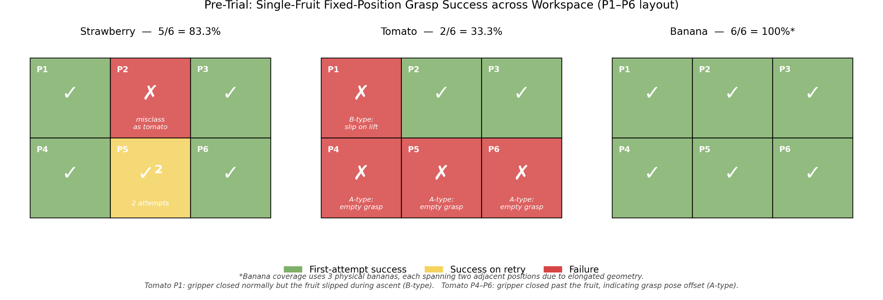
The results are summarised in Figure C, which mirrors the actual 2-by-3 spatial layout of the workspace. Banana achieved 6 out of 6, although it should be noted that we used 3 physical bananas, each spanning two adjacent positions because of

their elongated shape; this still gives full coverage of the six positions but the effective sample size is 3 rather than 6. Strawberry achieved 5 out of 6: the only miss was at P2, where the strawberry was misclassified as a tomato by the detector and was therefore skipped by the "strawberries-only" picker. Position P5 needed two attempts; the first one missed and the second one succeeded. Tomato performed clearly the worst, with only 2 out of 6 positions yielding a
successful pickup (P2 and P3). On the other four positions the gripper either closed past the fruit completely (P4, P5, P6, where stall values fell to 0.02–0.023) or held it briefly and dropped it during the lift phase (P1, where stall was 0.192 — within the normal grip range, yet the fruit still slipped). The overall first-attempt success rate of the pre-trial was 13 out of 18 (72.2%). The pre-trial therefore exposed the tomato as the weakest link in the system. Because tomatoes are smooth, fairly heavy, and roughly spherical, the rigid two-finger gripper does not have enough friction to hold them reliably, and small errors in the visual centroid translate into large errors in the actual contact geometry. The P1 case is particularly informative because it shows that even a stall value in the normal range does not guarantee a successful pickup — a finding we return to in Section 4.6. This finding directly motivates the soft gripper design described in Section [TBD: soft gripper section number].
4.3 Autonomous Mode: Repeatability (Trial 1 and Trial 2)
The two repeatability runs each used the same workspace layout: 3 bananas, 5 tomatoes, and 6 strawberries placed in standard upright orientation, with non-overlapping spacing. The picker ran the full "ALL (B → T → S)" sequence, meaning it cleared all bananas first, then all tomatoes, then all strawberries. Trial 1 finished in 6 minutes 35 seconds and reached a task completion rate of 13 out of 14 (92.9%). The single failure was F09, a strawberry: the detector identified it correctly with confidence 1.00, the picker commanded the close, the gripper closed to a stall of only 0.0226 (the lowest stall of any strawberry attempt in the trial, well below the typical successful-grip range of 0.05–0.08 for strawberries), the lift-and-place sequence completed, and the controller logged a successful pick. Visual inspection confirmed that the gripper had in fact closed without retaining the fruit. This is exactly the kind of false-positive log entry that motivated the visual-verification protocol described in Section 4.1, and it is reported under the per-fruit task completion rate (13/14) rather than under the log-derived per-attempt count.
Trial 2 had F08 missing from the workspace because of a placement mistake, so we report it as 13 out of 13 (100%) and finished in 8 minutes 57 seconds. Across both runs, basket placement accuracy was 100%: every fruit that was successfully picked up was dropped into the correct basket, with no misclassification at the placement stage.
These two runs are summarised in Figure A. The most encouraging part of the result is the cycle time. The average time per pick attempt was 28.2 seconds in Trial 1 and 29.8 seconds in Trial 2, with very small spread between attempts (the per-attempt distribution was tight in the 27.7 to 33.8 second range). This shows that the kinematics, motion planning, and gripper control loop are highly repeatable. The longer total time of Trial 2 was caused by the picker spending more attempts on tomatoes (some of them needed re-grasping), not by the cycle becoming unstable. Specifically, Trial 2 logged 9 tomato PICK_ATTEMPT events on 5 tomato fruits — of those 9 attempts, 3 had stall in the normal grip range (0.18–0.22) and successfully retrieved a tomato, 4 had stall around 0.02 (empty grasp), and 2 had marginal stall (0.05–0.07) on retries that eventually succeeded.
The cycle time itself can be decomposed qualitatively into four phases: detection (a single overhead capture and depth fusion), pre-grasp move from the survey pose to the fruit, grasp closure with stall confirmation, and lift-and-place from the fruit to the correct basket. Among these, the place leg is by far the longest because it traverses the largest joint distance, which is fixed by the workspace geometry and by the conservative slow_move_to_joints duration used for safety.
Trial 2 was about two minutes slower than Trial 1 not because the cycle became unstable, but because every failed attempt adds roughly one additional cycle of detection plus approach plus retry. This means cycle time is dominated by the
kinematic constants and the safety-tuned motion durations, not by the detection or planning layers, and is therefore a property of the platform rather than of the algorithm. Considering that this baseline performance covers detection, depth fusion, IK, gripper control, and basket sorting in a single closed loop running on the physical QArm, the autonomous baseline is a strong outcome for the project.

4.4 Autonomous Mode: Robustness (Trial 3)
Trial 3 deliberately introduced placements that we expected to challenge the system, in order to map out where the failure boundaries actually are. The same 14 fruits were used, with the following modifications: F03 (banana) and F04 (tomato) were placed touching each other; F05, F06, and F08 were inverted tomatoes; F09 and F11 were inverted strawberries; F13 and F14 were strawberries rotated more than 90 degrees from the canonical pose. The remaining fruits were placed normally.

The run finished in 6 minutes 56 seconds and achieved a task completion rate of 7 out of 14 (50%). The detailed breakdown is shown in Figure A. The failures split into three categories.
The first category is adjacent-fruit interference (F03 and F04). The detector did identify F03 as a banana, but the live detection frames captured at this moment (see Figure [TBD: GUI screenshot figure number]) show that F04 — the adjacent tomato — was confidently misclassified as a strawberry, with reported confidence 0.86 in one frame and 1.00 in a slightly later frame. Inspection of the detector source code explains this directly: the strawberry path (fruit_detector.py:320-321) accepts a red blob if either a green calyx signal exceeds 0.05 OR the contour circularity drops below 0.4. When the tomato is touching a banana, the banana's stem region or the contact shadow can leak green pixels into the bbox neighbourhood (the calyx signal is searched in the bbox plus 25 pixels of padding, fruit_detector.py:357-358), and the disturbed contour can also fall below the circularity threshold. Either pathway is sufficient to flip the label from tomato to strawberry. Because the picker was in the "banana phase" at this moment, the tomato had been misclassified into the strawberry queue rather than the banana queue, and the picker pursued the actual banana — but the gripper hit both fruits at once. The recorded stall values confirm this: banana attempt #3 in the Trial 3 log returned stall = 0.4300 and attempt #4 returned stall = 0.4727, meaning the gripper closed only to roughly 53–57% of the commanded position. Normal banana stall in this run was 0.18–0.22, so a stall above 0.4 is a clear signature of mechanical jamming on a hard object — consistent with the gripper being stuck on the harder, smoother tomato wedgedagainst the banana.

The second category is inverted-pose failure (F08, F09, F11). For inverted tomatoes (F08), the geometric centroid and the depth fusion together gave a target point that was offset from the actual contact surface, and the gripper closed past the fruit twice before we withdrew it. For inverted strawberries (F09 and F11), the failure mechanism is more interesting and is best explained directly from the picker source. The strawberry pick logic (picker_viewer.py:178-225) applies two empirical biases on top of the detected centroid: a 2 cm offset in the direction of the calyx (_STRAWBERRY_CALYX_BIAS_M = 0.02, with the direction taken from the unit vector from the body's widest-inscribed-disk centroid to the green-pixel

centroid), and a global x-axis offset of −3 cm (_STRAWBERRY_X_BIAS_M = −0.030, partially cancelling the controller's +5 cm

global x-bias to give a net effective +2 cm). The widest-inscribed-disk centroid algorithm (fruit_detector.py:277-298)

was tuned for upright strawberries, where the wide body forms the dominant projection from above and the algorithm

correctly places the centroid inside that body. On an inverted strawberry the projected outline changes shape: the

centroid algorithm tends to land near the calyx stem rather than inside the wide fruit body, and the calyx-direction unit

vector then points along the same axis. The 2 cm bias pushes the grasp another 2 cm in that direction, which lands the

gripper outside the actual contact surface. Both inverted strawberries (F09 and F11) produced an empty grasp on every

attempt, with stall values of 0.0206 and 0.0231 respectively in the Trial 3 log — consistent with the A-type empty-grasp

signature defined in Section 4.6.

The third category is detection rejection (F13 and F14). With the strawberry rotated more than 90 degrees from canonical,

the calyx is no longer visible from above, AND the side-profile of the strawberry looks more circular. Reading the

detector code, this causes both strawberry acceptance paths to fail: the calyx ratio drops below 0.05 (no green found) and

the circularity rises above 0.4 (failing the shape signal). The contour is therefore rejected before any Detection object

is produced, which is why the Trial 3 log contains no PICK_ATTEMPT entry for F13 or F14 — the picker simply never saw

them.

Notably, F05 and F10 are partial successes that show the system can sometimes handle adversarial poses. F05 was an

inverted tomato that we expected to fail (and had failed in earlier informal tests), but in Trial 3 it was picked cleanly

on the first attempt with stall 0.1321. F10 was a strawberry rotated about 45 degrees from canonical, which is below the

angle at which the side-profile becomes circular enough to defeat the shape signal; it was detected and grasped

successfully.

Although a 50% completion rate looks weak compared to Trial 1 and Trial 2, it should be read as a stress test. The drop

from a 96% baseline to 50% under adversarial input is informative because it tells us exactly which conditions break the

system, and the failure modes are structural and traceable rather than random.

4.5 Teleop Mode

The teleoperation test was carried out by two team members. The test rule was 6 fruits per operator (1 banana, 3 tomatoes,

2 strawberries), with 30 seconds of warm-up time on the keys before recording started. The original plan included a third

operator, but after watching the first two attempts, both completed testers and the third tester agreed there was no

value in attempting again, and the third tester declined further participation. We chose to report this as a usability

finding rather than as missing data.

The combined result was 0 out of 12. Neither operator was able to place a single fruit in the correct basket. Tester 1

took 8 minutes 57 seconds, recorded 4 grip failures and 4 collision events, and rated the experience 1 out of 5. Tester 2

took 4 minutes 47 seconds, recorded 3 grip failures and 3 collision events, and likewise rated the experience 1 out of 5.

The tester-2 run was shorter only because the operator gave up earlier after experiencing the same failures. Both runs

failed in essentially the same way: any fruit that was picked up gradually slipped out as the operator tried to move it

toward the basket, and fine adjustments near the pick pose caused the gripper to crash into the workspace surface.

We investigated the cause directly in the source code. Two issues were found. First, the GUI labels the manual jog buttons

as "base frame, 2 cm step", and indeed the function _teleop(dx, dy, dz) in main_gui.py:512-526 reads the current joint

angles, runs forward kinematics to get the end-effector position, adds the requested Cartesian step, and then calls

inverse kinematics with gamma = 0.0 to get the new joint target. The actual motion is then a joint-space interpolation.

Because the IK solution under the fixed orientation constraint redistributes all four joint angles on every step, the

joint-space path between two close Cartesian targets does not stay on the requested straight line, and the end-effector

tends to drift downward in Z. Operators reported exactly this behaviour: pressing X+ or Y+ caused the gripper to also sink

toward the table.

Second, the gripper command in teleop is anchored to the readback of the actual gripper position rather than to the

operator's last commanded value. At line 515 of main_gui.py, every teleop step reads the current gripper value from the

driver via driver.read_all() and then passes that value into _safe_move_to_joints (line 524) as the gripper setpoint for

the upcoming move. If the operator has closed the gripper on a fruit and the fruit subsequently slips slightly under load,

the actual gripper opens slightly to match, the readback returns the opened value, and the next teleop press commands

that opened value. The grip therefore drifts in the same direction as the slip, rather than being held at the original

closure target. Each subsequent press reinforces the slip rather than correcting it, and the fruit eventually falls out

before reaching the basket.

These two control-layer issues fully explain the 0% result. The teleop test is therefore best read as a control group:

when the autonomous wrapper is removed, the underlying low-level layer is not yet usable for human operators, which makes

the autonomous mode's 96% baseline result look more meaningful by comparison.

4.6 Failure Mode Analysis

To make the failure pattern across all four test modes easier to interpret, we extracted the gripper stall value from

every recorded pick attempt and grouped it by fruit type and outcome. The result is shown in Figure B and reveals three

clear classes of failure with strikingly clean separation in the stall axis.

The first class is the empty-grasp failure, which we call A-type. In these cases the gripper closes almost completely

(stall in the 0.02 range) because there is nothing inside it. This pattern appears at five tomato attempts in the

pre-trial (T#4 through T#8, stall 0.020–0.023), at the inverted strawberries F09 (stall 0.0206) and F11 (stall 0.0231) in

Trial 3, and at the inverted tomato F08 in Trial 3. The root cause is a wrong grasp pose, either from the type-specific

bias applied downstream of detection (the strawberry +2 cm calyx bias and −3 cm x bias defined at

picker_viewer.py:178-199, the tomato +2 cm x bias at line 201, with banana untouched) or from the widest-disk centroid

algorithm landing on the calyx stem rather than inside the body when the strawberry is in a non-canonical orientation (as

discussed in Section 4.4).

The second class is the slip-during-ascent failure, which we call B-type. The stall is in the normal range for a

successful grip (around 0.19) but the fruit slips out during the lift phase. The clearest example is the tomato P1 in the

pre-trial, where stall was 0.192 — well within the typical successful-grip range — yet the tomato fell out of the gripper

during ascent. This kind of failure cannot be detected from the stall value alone, because the gripper looks like it

grabbed something. This is an important lesson: stall is a necessary but not sufficient signal for grasp success, and any

future closed-loop verification will need a second sensor (for example, a low-cost weight sensor on the gripper or a

downward-looking camera between the fingers) to confirm retention through the lift phase.

The third class is the adjacency failure (F03 and F04 in Trial 3), where the stall is anomalously high (0.4300 and 0.4727

respectively) because the gripper is mechanically jammed between two fruits. The exact stall values are diagnostic: a

stall of around 0.20 is the natural compliance of the rigid finger pads against soft fruit material, while a stall above

0.4 means the gripper has stopped against something rigid enough to prevent further closure. In this case it was the

harder tomato wedged against the softer banana.

A useful way to read these three classes together is to ask which layer of the system is responsible for each. A-type

failures originate in the perception-to-action interface: the detector finds the fruit and reports a centroid, but the

bias logic and centroid algorithm that translate the centroid into a grasp pose are not robust to non-canonical

orientations. B-type failures originate in the physical actuation layer: the grasp pose is roughly correct, the gripper

closes, but the friction and geometry of the rigid two-finger design cannot retain the fruit through the lift. Adjacency

failures originate in the planning layer: the picker has no notion of neighbours and approaches one target without

considering whether the gripper width clears the next one.

Mapping the failures to layers in this way also clarifies that no single fix would have rescued all four test modes. The

autonomous baseline already filters out adjacency by spacing, the pre-trial already filters out adjacency by isolation,

but neither isolates the grasp pose problem from the gripper friction problem. This is why the soft gripper proposal in

Section [TBD: soft gripper section] is paired with a planned upgrade to point-cloud-based grasp pose estimation rather

than treated as a single solution. A-type failures need better grasp pose estimation, for example using the full depth

point cloud rather than fixed type-specific biases. B-type failures need either a higher-friction or compliant gripper,

which is exactly what motivated the soft gripper design. Adjacency failures need a collision check at the planning stage

and ideally a multi-target awareness so that the picker does not approach a target whose neighbour is within gripper

width.

It is also worth noting that the current system does not act on the stall value at all — every PICK_ATTEMPT proceeds

through the full place sequence regardless of how empty the grasp was. Adding a stall-threshold check after CLOSE_GRIPPER

(for example, abort and re-detect if stall < 0.05 for tomato or strawberry) would catch every A-type failure at the source

and convert it into a retry, with no hardware changes. This is a small change with a large expected impact on the

per-attempt success rate, and we list it as a future-work item alongside the soft gripper.

4.7 Aggregate Results

Figure D summarises the overall picture. The autonomous baseline (Trials 1 and 2 combined) reached 26 out of 27 (96.3%),

the autonomous robustness run reached 7 out of 14 (50.0%), the pre-trial reached 13 out of 18 (72.2%), and the teleop test

reached 0 out of 12 (0%). The outcome composition in panel (b) shows that the baseline failures are almost entirely

vision-related (the single F09 empty grasp), the robustness failures span all major failure categories (adjacency,

inverted-pose, detection rejection), the pre-trial failures are dominated by physical (slip and empty) failures on the

tomato, and the teleop failures are uniformly caused by the control-layer drift problem.

The four numbers should also be read with their respective sample sizes in mind. The autonomous baseline of 26/27 is over

a single workspace layout repeated twice, so it characterises the system under nominal conditions but not under day-to-day

setup variance. The robustness 7/14 was a deliberately stressful single instance, and the failure breakdown is more

informative than the percentage itself. The pre-trial 13/18 has a small per-cell sample (one attempt per position per

fruit type), so the position-level statistics are descriptive rather than statistically significant. The teleop 0/12 is

small but the failure mode is uniform and structural, so the result generalises beyond the sample.

Reading the four numbers together tells one consistent story. The autonomous control logic, the kinematic chain, the cycle

scheduling, and the basket sorting layer are all working well: when the inputs are within their nominal range, the system

is reliable and reasonably fast (~29 s per pick attempt with very small spread). The remaining weaknesses are

concentrated at two specific layers: the grasp pose estimation, which is currently driven by fixed offsets and a centroid

algorithm that do not generalise to inverted or adjacent placements, and the rigid two-finger gripper itself, which

struggles with smooth, heavy fruits. Both of these are realistic targets for future iterations and are discussed further

in Section [TBD: future work section].

The four-mode test design itself proved valuable. Running a fixed-position pre-trial separately from the autonomous trials

made it possible to attribute specific failures to specific layers; without the pre-trial, the tomato slip problem would

have been confused with detection error in the autonomous data. Similarly, running the robustness test as a separate

adversarial run kept the baseline numbers clean and gave us a structured failure inventory. Running the teleop test as a

control group kept the autonomous result interpretable by showing what the underlying low-level layer looks like with the

autonomous wrapper removed. We recommend this layered structure for future iterations of the project, since the same

teardown can be re-applied after the soft-gripper upgrade or after a detector retrain.
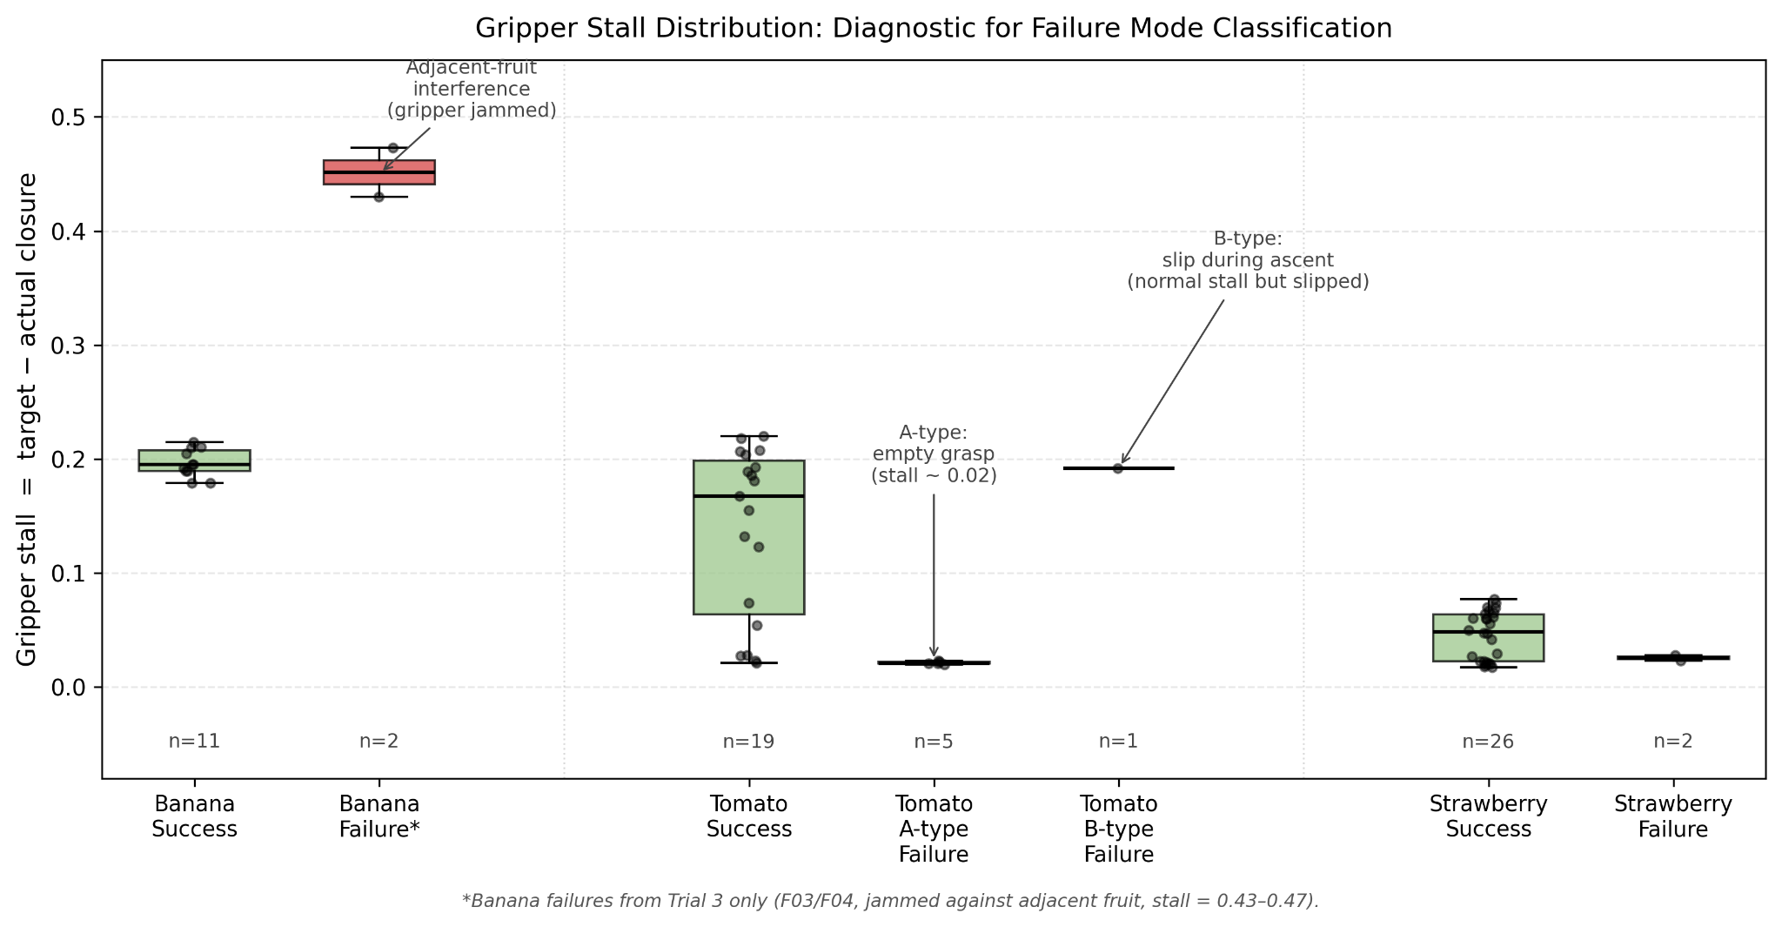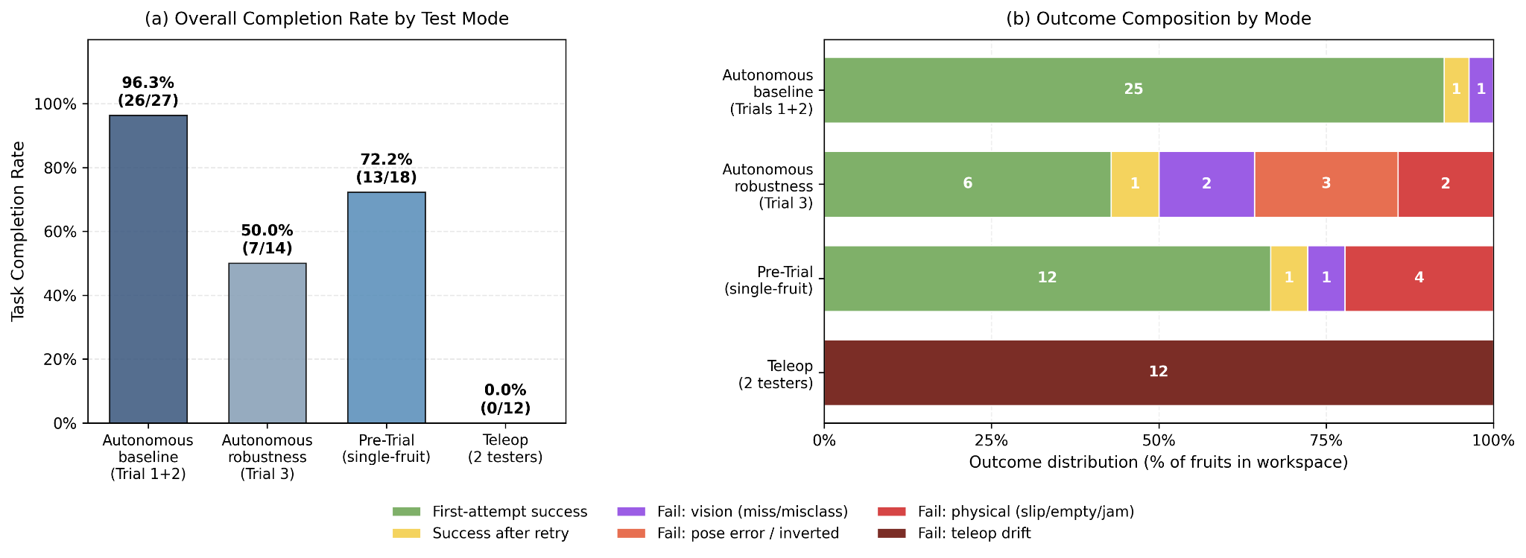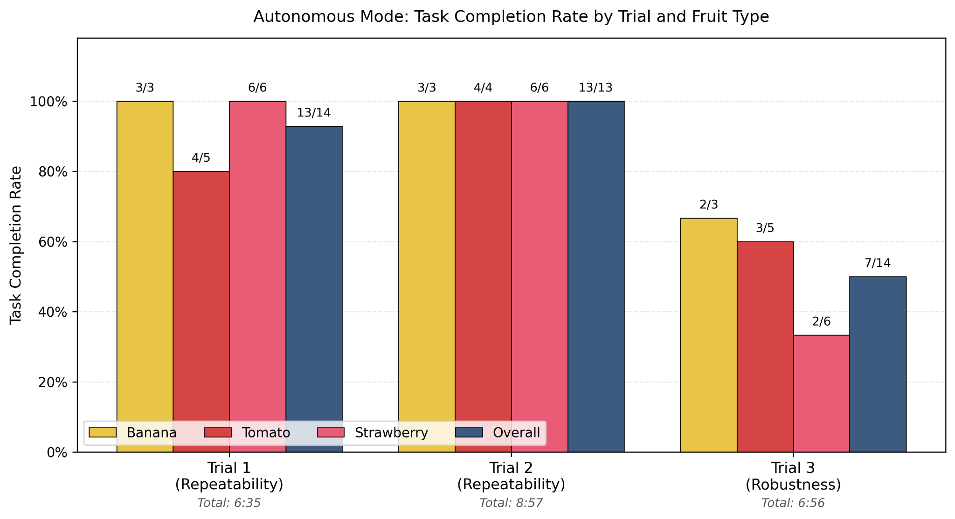

Problem and Resolution: Replacing the Missing QUARC License with the Quanser Python SDK

1. The Problem
Our original control plan for the QArm was based on the standard Quanser workflow, in which the controller is built as a Simulink model and deployed to the robot through the QUARC real-time toolchain. During the first lab session after the Easter break, we discovered that none of the workstations available to our group had an active QUARC license. The Simulink build step consistently failed at the deployment stage with a license error, and the same error reappeared on every machine we tried. Because the rest of our planned pipeline, including the trajectory generator, the gripper command path, and the vision-to-pick handover, all assumed that QUARC would manage the real-time loop, the missing license blocked the project at its lowest layer. Without a working way to send any joint command to the hardware, we could not even verify that the arm was wired correctly, let alone start testing the higher-level sorting logic.

2. Action Taken
Once we confirmed that the failure was a licensing issue rather than a hardware or installation fault, we raised the problem with one of the lab teaching assistants during the next session. The TA explained that QUARC is one of two supported ways to drive the QArm and is not strictly required for our use case. The other path is the Quanser Python SDK, a library that exposes the same low-level hardware functions QUARC relies on internally but makes them available through a plain Python API. The SDK is shipped with the lab installation by default, runs on a standard Python interpreter, and does not need a QUARC seat in order to read sensor data or send actuator commands.

3. Solution and Outcome
Acting on this advice, we redesigned the control stack as a pure Python pipeline built on top of the SDK. A thin driver layer reads joint angles, end-effector position, and gripper state directly from the QArm card, then writes commanded joint targets and gripper setpoints back to the same card at a fixed cycle rate. All higher-level logic, including forward and inverse kinematics, trajectory interpolation, vision processing, and the sorting state machine, was moved into Python rather than Simulink. Simulink was kept only as a presentation layer for the demonstration and was given no responsibility for real-time control. With this change in place, the entire system became license-independent. Every result reported in this document was produced under the SDK pipeline, on a standard lab machine, without any QUARC activation, and the switch removed what had been the single biggest blocker to making progress in the early weeks of the project.

